Theraplay® Peer Support – Dorset

For delegates who have attended Level one Theraplay® and MIM Skills training. A peer support group looking at implementation and use of Theraplay®.

- Tuesday 25th February 2020. 10:00- 12:00. Theraplay® Check Ins.
Kinson Hub, Wimborne Road, Bournemouth. BH119AW.

- Tuesday 26th May 2020. 10:00-12:00. Working with Parents. Share recordings.
Kinson Hub, Wimborne Road, Bournemouth. BH119AW.

- Friday 10th July 2020. 10:00 -12:00. MIM refresher. Share recordings.
4 White Hill, Puddletown, Dorchester, Dorset, DT28SB

- Tuesday 25th September 2020. 10:00-12:00.
Kinson Hub, Wimborne Road, Bournemouth. BH119AW.

- Tuesday 10th November 2019 10:00 – 12:00. Topic: Share recording.
4 White Hill, Puddletown, Dorchester, Dorset, DT28SB

First peer support group is free of charge to see if groups suits practitioner. Donations to cover cost of venue hire. bookings. Email: waveconnections@outlook.com or Tel: 07850 732303

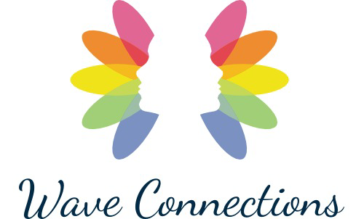
‘Creating A Space To Blossom’

